UNEP Emissions Gap Report 2025
Chapter 2 Global Emissions Trends

Lead Authors: William F. Lamb^{1,2}, Minal Pathak³
Contributing Authors: Monica Crippa^{4,5}, Diego Guizzardi⁴, Giacomo Grassi⁵, Glen P. Peters⁶, Julia Pongratz^{7,8}
1 Potsdam Institute for Climate Impact Research (PIK), Member of the Leibniz Association, Potsdam, Germany
2 Priestley Centre for Climate Futures, University of Leeds, United Kingdom
3 Climate Institute, Ahmedabad University, India
4 European Commission, Joint Research Centre (JRC), Ispra, Italy
5 Unisystems S. A., Milan, Italy
6 CICERO Center for International Climate Research, Norway
7 Ludwig-Maximilians-Universität in Munich, Germany
8 Max Planck Institute for Meteorology, Hamburg, Germany
Key messages
- Global greenhouse gas emissions in 2024 reached a record high of 57.7 GtCO2e, growing by 2.6 per cent (1.4 GtCO2e). The growth rate was high compared to recent years and another opportunity was missed to peak emissions.
- A large share of this years’ emissions growth was due to deforestation and forest degradation emissions in the land use, land-use change and forestry (LULUCF) sector. However, emissions from fossil fuels also continued to increase.
- Most countries within the G20 registered an increase in GHG emissions, excluding LULUCF.
- The highest absolute growth in total GHG emissions, excluding LULUCF was observed in India and China, while Indonesia recorded the fastest relative growth in emissions.Several historic high emitting countries such as the USA and Russia have much higher emissions compared to the global average and increased their emissions in 2024.
- Renewable energy deployments and climate policies avoided even higher emissions growth in 2024, but increased effort will be required to bring a peak in global GHG emissions.

Introduction
This chapter assesses greenhouse gas (GHG) emissions trends up to and including 2024. It aims to describe emissions trends from multiple perspectives, including total emissions across gases and sources (section 2), emissions by major sectors (section 3), and the emissions of major emitters, including their per capita and historic contributions (section 4). These different perspectives offer insight into the drivers of emissions, as well as inequalities in contributions to climate change.
As in previous years, the Emissions Gap Report focuses on total net GHG emissions across all major groups of anthropogenic sources and sinks reported under the United Nations Framework Convention on Climate Change (UNFCCC). This includes: CO₂ emissions from fossil fuels and industry (fossil CO₂); CO₂ emissions and removals from land use, land-use change and forestry (LULUCF CO₂); methane emissions (CH₄); nitrous oxide emissions (N₂O); and fluorinated gas (F-gas) emissions covered under UNFCCC reporting. This set of sources is consistent with global Integrated Assessment Modelling (IAM) benchmarks reported in chapter 4, as well as other major assessments (Forster et al., 2024; IPCC, 2022). It excludes ozone depleting substances regulated under the Montreal Protocol as well as the cement carbonation sink, neither of which are currently covered in UNFCCC reporting. It also excludes fire emissions that are not directly caused by humans. Including these various sources would increase global emissions by approximately 1.8 GtCO₂e per year (Lamb et al., 2025). Where estimates are reported at a national level, these are based on territorial accounting.
The reporting of net LULUCF CO₂ emissions is also consistent with previous years. The global bookkeeping approach is used to report global estimates of net LULUCF CO₂ emissions, and the national inventory approach is used to report national estimates of net LULUCF CO₂ emissions. This ensures that global estimates are consistent with chapter 4, as well as the carbon cycle and climate science literature; while national estimates are consistent with those reported by countries to the UNFCCC. As this chapter reports, total net LULUCF CO₂ emissions differ substantially between these two approaches, due to known differences in system boundaries and other assumptions (Grassi et al., 2018). A translation between global emissions based on bookkeeping models and the national GHG inventories reported by countries is available and is updated annually (European Commission, 2025; Friedlingstein et al., 2025; Schwingshackl et al., 2022) (see Box 2.1).
The principal sources in this chapter include the EDGAR dataset for fossil CO₂, CH₄, N₂O and F-gas emissions (Crippa et al., 2025); the Global Carbon Budget for global LULUCF CO₂ estimates, taking the average of four bookkeeping models (Friedlingstein et al., 2025); and (European Commission, 2025) for national inventory-based LULUCF CO₂ (with updates to the latest inventories for the major emitters). Throughout this report, 100-year global warming potentials from the latest Intergovernmental Panel on Climate Change Sixth Assessment (IPCC AR6) Working Group I Report (Forster et al., 2021) are used where GHG emissions are aggregated to CO₂ equivalents. Alternative metrics can be used to highlight the differing impacts of short lived gases, but are not explored here. Further methodological and data choices are detailed in the technical appendix of this chapter, which is available online.

Global emissions trends
Ten years on from the Paris Agreement, global GHG emissions continue to increase. In 2024, they reached a record high of 57.7 GtCO2e, growing by 2.6 per cent (1.4 GtCO2e) from the previous year (figure 2.1, table 2.1) (Crippa et al., 2025). This rate is fast compared to emissions growth in the 2000s (on average 2.2 per cent per year), the 2010s (0.6 per cent per year) and last year (1.6 per cent). At the same time, atmospheric CO₂ concentrations rose to [PLACEHOLDER] ppm in 2024 [WMO 2024 REFERENCE] and will continue to do so until annual CO₂ emissions are reduced sufficiently to be balanced by removals (net-zero).
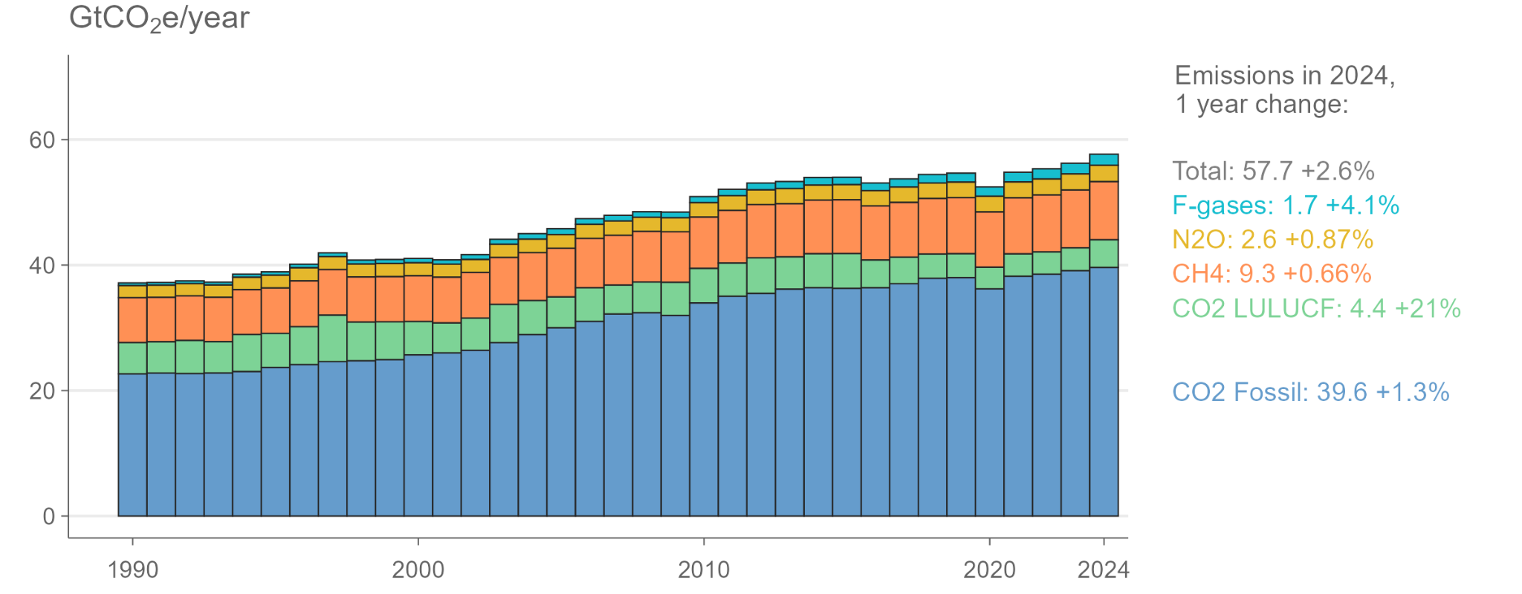Figure 2.1: Total net greenhouse gas emissions by gas. Sources: Crippa et al. (2025), Friedlingstein et al. (2025).
Fossil CO₂ emissions account for approximately 69 per cent of current GHG emissions. These emissions are driven by the combustion of coal, oil and gas in the energy sector, as well as industrial processes associated with the manufacture of metals, cement, and other materials (Figure 2.2). Multiple datasets agree that fossil CO₂ emissions grew in 2024: EDGAR (used here) estimates an increase of 1.3 per cent or (Crippa et al., 2025), compared to +1 per cent reported by the Energy Institute (2025) (energy sector only) and +0.8 per cent forecast by the Global Carbon Budget (Friedlingstein et al., 2025). Overall, the change in Fossil CO₂ emissions was substantive at +0.55 GtCO₂, but not as fast as last year when the increase was +0.88 GtCO₂.
Together, CH₄, N₂O and F-gas emissions account for about 24 per cent of total GHG emissions. All these gases continued to grow in 2024, with F-gas emissions the fastest at 4.1 per cent, followed by CH₄ at 0.87 per cent and N₂O at 0.66 per cent (Figure 2.2). Anthropogenic CH₄ emissions are currently the second largest source of GHG emissions, and are mainly attributable to agricultural sources including ruminant livestock, manure management and rice cultivation. Venting from oil and gas operations, coal mine methane leaks, and waste management are also significant sources (figure 2.2).
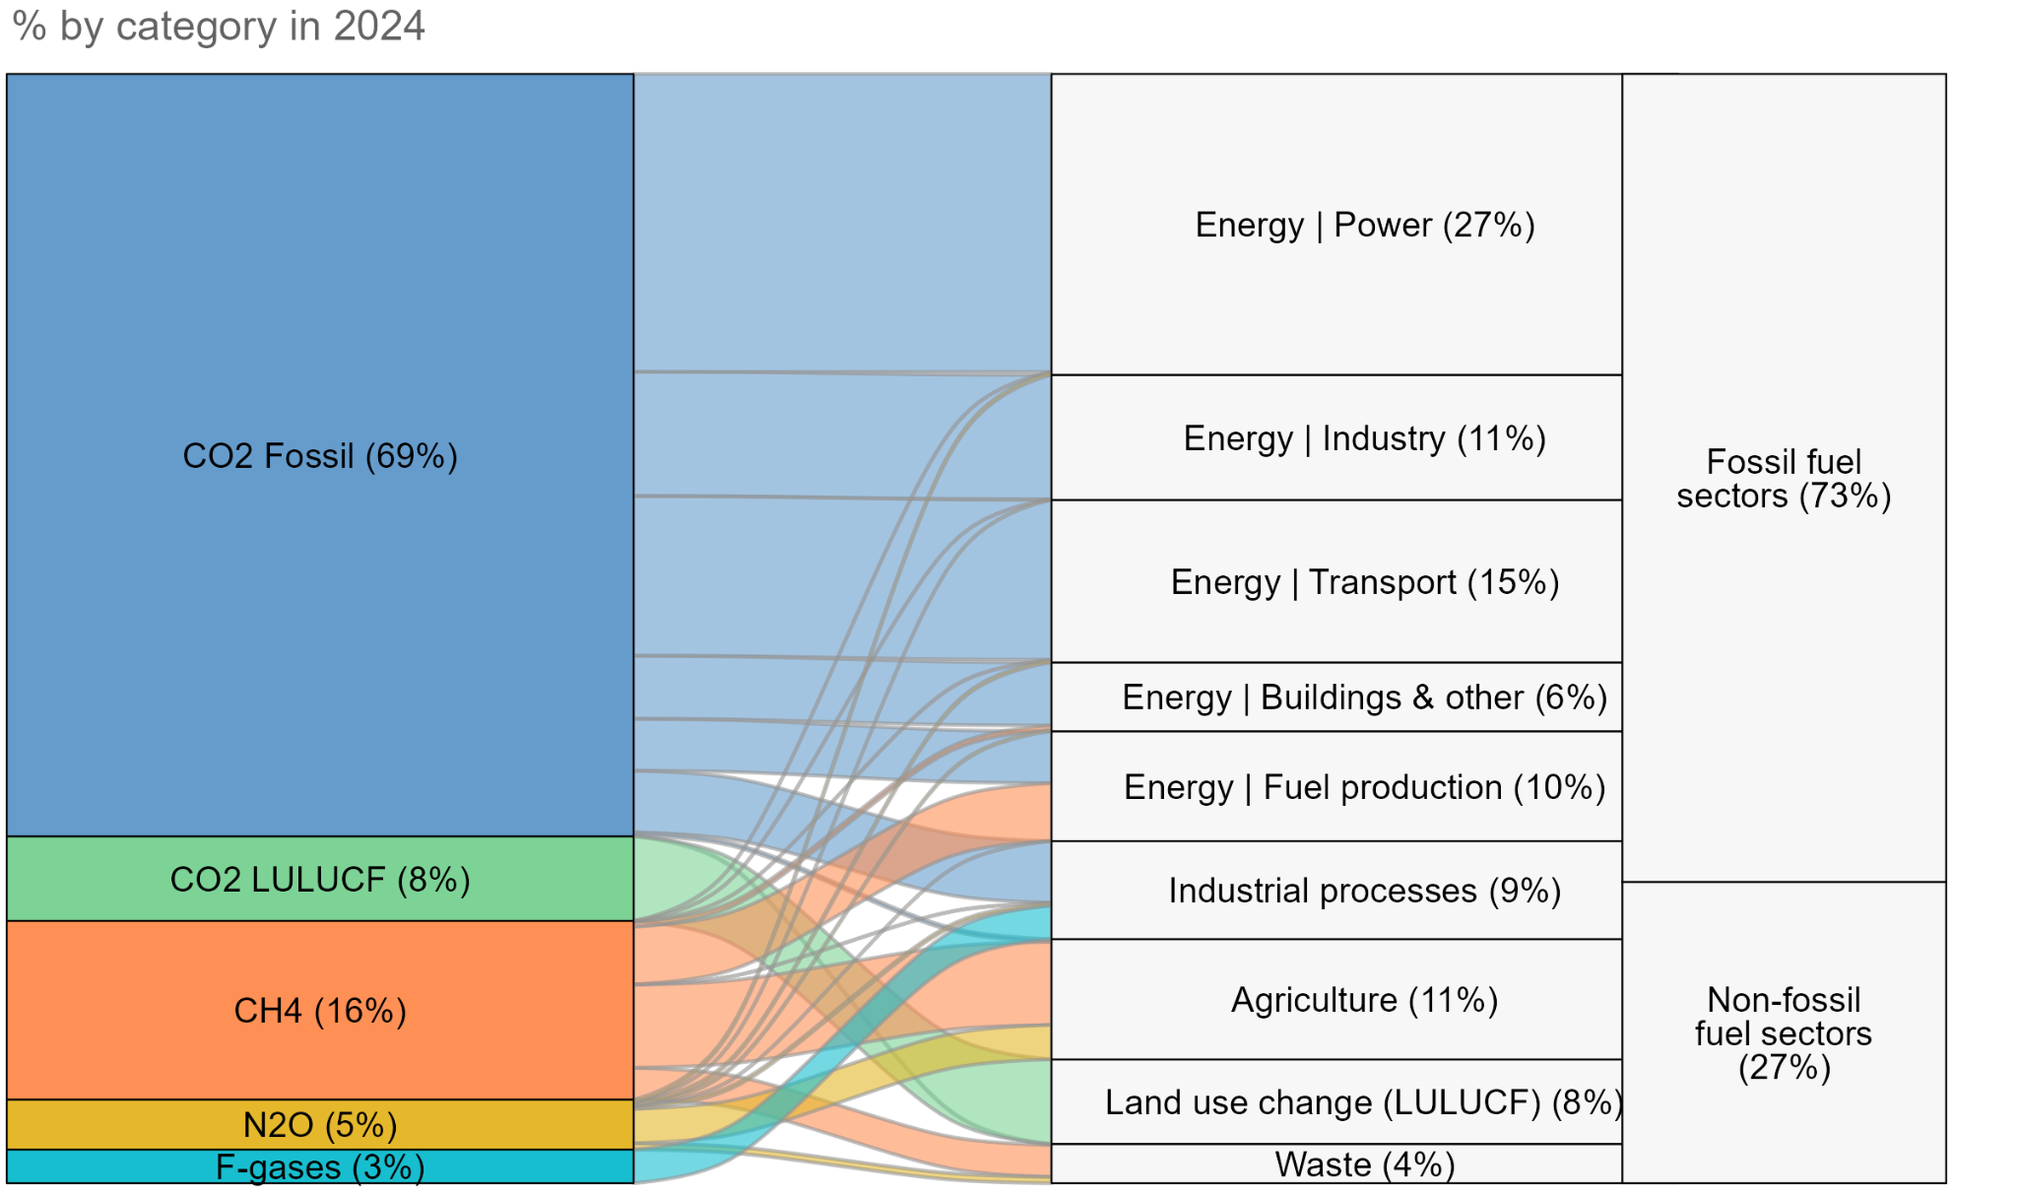Figure 2.2 Total net greenhouse gas emissions by gas, sector and fossil/non-fossil category. Sources: Crippa et al. (2025), Friedlingstein et al. (2025).
Total emissions across all gases that are associated with fossil fuel extraction, production and combustion were 42 GtCO₂e in 2024, accounting for ~73% of the total (Figure 2.2). Most growth in emissions over the past few decades was also associated with fossil fuels (Appendix figure 1).
Despite the key role of fossil fuels in driving total emissions, deforestation and land use change was decisive for the rapid increase in 2024 emissions. Global net LULUCF CO₂ emissions - using the global bookkeeping approach - was projected to increase by 21 per cent (0.77 GtCO₂) in 2024 and was thereby responsible for the largest share of the overall change in emissions (53% compared to 36% for Fossil CO₂). The bookkeeping approach calculates emissions and removals based on land-use activity data and carbon response curves, but extrapolates the most recent year (here 2024) based on the interannual variability of the emission estimates from tropical deforestation and degradation fires, and Southeast Asian peat fires (Friedlingstein et al., 2025). Emissions from tropical deforestation and degradation fires in South America were among the highest ever recorded since 1997 at 1.2 GtCO₂ in 2024 (van der Werf et al., 2017; Friedlingstein et al., 2025). They were likely exacerbated by El Niño conditions that started in mid-2023 and ended in mid-2024, which drive increased temperatures and drought risk, and are known to increase the odds that anthropogenic fires used for agricultural management or forest clearing activities ‘escape’ and have larger than anticipated effects (Friedlingstein et al., 2025; Lamb et al., 2025). The dry conditions even caused fires and drove emissions up in the wetlands of the Pantanal. In contrast to South America, land-use emissions from Southeast Asia have dropped in 2024, as the El Niño conditions ceased (Friedlingstein et al., 2025). The interactions between climate change, deforestation and biodiversity are becoming important drivers of emissions, as well as key sources of mitigation potential in the coming decades (see Box 1).

Box 1: Deforestation, emissions and impacts on nature and health

At COP26 in Glasgow, over 100 countries signed a pledge to halt or reverse deforestation (UNFCCC, 2021). However, global primary forest loss has still not decreased and deforestation continues to drive emissions and impact biodiversity (Global Forest Watch, 2025). Although a substantial amount of CO₂ is removed from the atmosphere through land-use activity already, estimated at about 2.2 GtCO₂ taken up and stored per year on average 2013-2022 through afforestation, reforestation, and long-lived wood products globally (Pongratz et al., 2024), emissions from deforestation still outdo these carbon dioxide removals by a factor of about two at the moment (Friedlingstein et al., 2025).

The year 2024 was another year of extensive forest and tree cover loss in the tropics, much of this driven by wildfires. Global primary forest loss amounted to 6.7 million hectares (Mha), an increase of 80% over the previous year (3.74Mha). In the same year, annual tree cover loss reached a record high with approximately 30 Mha globally. Forest fires were responsible for a significant proportion (45%) of this loss in the tropics (Global Forest Watch, 2025). The highest forest loss in 2024 was observed in Brazil, with nearly 65% lost on account of forest fires. Also temperate and boreal forests were anomalously affected by wildfires in 2024, most notably Canada, where the extreme wildfire season of 2023 persisted into 2024.

It is important to note that fires often occur as part of natural cycles or in response to interannual variability such as ENSO cycles. In such cases, their impacts on emissions, if not compensated by regrowth, are not attributable to human activity. However, an increase in frequency and intensity of droughts and heatwaves associated with human-induced climate change has contributed to an increase in likelihood of large-scale wildfires in some parts of the world (Copernicus 2024).

The impacts of wildfire on local populations including loss of lives, impacts on property and infrastructure and other economic impacts underscores the need to look at these events beyond emissions. Record burned areas from extreme wildfires resulted in millions being exposed to hazardous air pollution (Kolden et al., 2025). In California, more than half of the homes destroyed by wildfires were located in low-income areas (Reining et al., 2025).

Between 2023 and 2024, the loss of primary forests unrelated to fires increased by 14%, mostly driven by conversion of forests to agriculture (Global Forest Watch, 2025). Major economies, including Brazil, Indonesia, China, the United States and Europe, are responsible for consuming agriculture and forest goods that are linked to deforestation, often from outside their own territories (West et al., 2025). About one quarter of total greenhouse gas emissions from land-use are embodied in trade in recent years, with marked contributions linked to, for example, the export of soybean from Brazil or palm oil from Indonesia to Europe or China (Hong et al., 2022).

Forests have a significant role in carbon storage, regulating local and regional climate (Pongratz et al., 2021),and supporting biodiversity and livelihoods. Increased forest loss has significant consequences for carbon emissions and could intensify climate change and push the world back on biodiversity goals. There is growing evidence food supplies globalising and causing unprecedented impacts on species loss, especially in biodiversity rich regions (Boakes et al., 2024; Wiebe and Wilcove, 2025).
Table 2.1 Total global emissions by source
GtCO2e | 2010-2019 (average) | 2022 | 2023 | 2024
GHG | 53.3±5.4 | 55.3±5.1 | 56.2±5.2 | 57.7±5.5
Fossil CO₂ | 36.3±2.9 | 38.5±3.1 | 39.1±3.1 | 39.6±3.2
LULUCF CO₂ (global bookkeeping) | 4.9±3.4 | 3.5±2.5 | 3.6±2.5 | 4.4±3.1
LULUCF CO₂ (national inventory*) | -3.6±-2.5 | -4.2±-2.9 | -4.2±-3 | -
CH₄ | 8.6±2.6 | 9.1±2.7 | 9.2±2.8 | 9.3±2.8
N₂O | 2.4±1.4 | 2.5±1.5 | 2.6±1.5 | 2.6±1.6
F-gases | 1.2±0.35 | 1.6±0.48 | 1.7±0.5 | 1.7±0.52
Note: Non-CO₂ greenhouse gases are converted to CO₂ equivalents using global warming potentials with a 100-year time horizon from the IPCC WGI AR6 (Forster et al., 2021). * Inventory-based LULUCF CO₂ is excluded from total GHG emissions, but all other sources are included. Sources: Crippa et al. (2025), Friedlingstein et al.(2025), European Commission (2025).
Although LULUCF CO₂ emissions were high in 2024, they remain below the average for the 1990s and 2000s where annual emissions were often above 5 GtCO₂ (Appendix Fig 2). They are also based on an early projection of land use activity with relatively high uncertainties (Friedlingstein et al., 2025). This category of emissions is generally considered to have the largest uncertainties of all gases considered here, both in terms of absolute levels and year to year trends (Appendix Fig 3).
An additional complication of LULUCF CO₂ emissions is that global bookkeeping and national inventory-based accounts diverged by more than 8 Gt CO₂ in the period 2010-2019 (Grassi et al., 2025) (table 2.1; Appendix Fig 2). This is due to known differences in system boundaries between each approach, in particular the fact that bookkeeping models consider only “direct” human-induced fluxes as anthropogenic (e.g. deforestation, afforestation and other land-use-related vegetation changes), whereas national inventories typically also include most of the “indirect” human-induced fluxes (e.g. enhanced vegetation growth due to increased atmospheric CO₂) that occur on managed land (Grassi et al., 2021). As a result, national inventories globally sum up to a small net LULUCF CO₂ removal, but include a large portion of removals that are not the result of management action and will not be sustained once atmospheric CO₂ levels stabilise and decline (Gidden et al., 2023). This has significant implications for tracking national and global emissions, and for evaluating collective progress towards the Paris Agreement goals (see Box 2).

Box 2: Implications of different definitions of anthropogenic land use emissions

Land use is essential in the path towards net zero. For example, recent studies have shown the LULUCF sector accounts for up to one quarter of pledged mitigation effort in the NDCs (Roman-Cuesta et al., 2025). However, the mismatch between global bookkeeping and national inventory-based LULUCF estimates due to different definitions of what to count towards anthropogenic land-use fluxes complicates the assessment of the role of land use, and in addition has important implications for evaluating collective climate progress (Allen et al., 2025; Gidden et al., 2023; Grassi et al., 2021, 2018).

A recent IPCC Expert Meeting (IPCC, 2024) brought together key experts from global models, Earth observation, and national GHG inventories to foster a common understanding, promote collaboration and translate between different estimation approaches. An important question concerns the direction of this translation. While the direct observations typically used in national GHG inventories cannot accommodate the global model approach, global models are more flexible and can, in principle, be adapted to approximate inventory-based methods. This understanding is reflected in the approved outlines for the IPCC 7th assessment report (IPCC, 2025), which indicate that estimates and scenarios for land use CO₂ fluxes will align with national inventory definitions.

Furthermore, the implications of this alignment for emission pathways at both global and national levels must be clearly communicated (Grassi et al., 2025), including the fact that under the national inventory definition, the carbon budget is smaller and that achieving net-zero CO₂ alone is insufficient to halt global warming (Allen et al., 2025).

The ultimate goal is to achieve more credible and comparable LULUCF estimates across communities, enabling a more consistent and confident assessment of collective climate progress. This will require efforts from both the GHG inventory community — by enhancing transparency and the quality of estimates — and the global modeling community, which should improve translation methodologies and implement them at the country level. At the same time, policymakers need to understand the implications and scale up their climate targets accordingly (Allen et al., 2025; Grassi et al., 2025). This is particularly important for forest-rich countries, where the contribution of “natural” sinks to climate targets can be significant.

Emissions trends of major sectors
When emissions are allocated to major economic sectors, power generation was the largest contributor in 2024 at 15.6 GtCO₂e, followed by transport (8.4 GtCO₂e) and industry (6.5 GtCO₂e) (Figure 2.2; Appendix Figure 4). Emissions grew across most sectors in 2024, but growth was particularly pronounced in international aviation (+7.4 per cent). Robust emissions growth also occurred in the solid fuel production sector (+2.5 per cent); from fuel combustion in the industry sector (+2.1 per cent); as well as from industrial processes in the metals (+1.8 per cent) and chemicals (+1.7 per cent) sectors. There was a significant decrease in process emissions from cement (-3.4 per cent), primarily occurring in China (Andrew, 2025) where a slowdown in construction is underway.
Focusing on the energy sector, overall energy demand increased by 2.2 per cent in 2024, which was higher than the average rate of demand increase observed between 2013 and 2023 (IEA, 2025a). On the supply side, the demand for coal based power generation increased by 1% in 2024, however, there has been a progressive decline in the growth rate as well as its share in the total energy mix (IEA, 2025a). 2024 was another record year for renewable electricity generation (EMBER, 2025). Combined with a recovery of hydropower generation, much of the increase in energy demand in 2024 was met by non-fossil sources (IEA, 2025a). One recent estimate suggests that renewable energy development led to the avoidance of an additional 9.8 GtCO2 in 2024 compared to a counterfactual scenario where wind, solar, nuclear and hydropower were not available (Deng et al., 2025). The increased adoption of renewable energy combined with the declining share of thermal power, and energy efficiency improvements have resulted in a steady decline in the global CO₂ intensity of electricity since 2007 (Peng et al., 2025).
Despite positive trends on the supply side, 2024 was also a year of extreme heat waves around the globe, which pushed up electricity demand for cooling (EMBER, 2025; IEA, 2025a). In addition, a combination of factors including increasing consumption in the industry sector, electric vehicles, data centers and artificial intelligence along with the progressive rebound of the aviation sector since the COVID-19 pandemic led to an overall increase in energy related 2024 emissions (EMBER, 2025; IEA, 2025a).
Growth in sales of new electric cars continued in 2024, increasing by 25 per cent compared to previous year. China continues to lead, followed by the US. China’s EV car market benefited significantly with the introduction of a new trade-in scheme that offers incentives to replace older vehicles (IEA, 2025b). Another noteworthy trend is the steady increase in electricity demand from AI including data centres and associated infrastructure, which accounted for around 1.5 per cent of global electricity consumption in 2024 (IEA, 2025c). There are concerns that the pace and scale of AI adoption and associated infrastructure needs is undermining progress on renewable energy (Lee, 2025). From a macroeconomic perspective, the future growth of AI and associated emissions is uncertain and depends significantly on gains in efficiency; it is also likely to be small relative to the overall energy sector emissions (IEA, 2025c). There is a need to further understand the full range of impacts associated with near-term digitalisation trends.

Emissions trends of the top emitters
Currently, the six largest emitters in terms of total GHG emissions are China, the United States of America, India, the European Union, the Russian Federation and Indonesia. Preliminary estimates for 2024 (which exclude national-level LULUCF CO₂ for which data is only available up to 2023) show an increase in GHG emissions compared with 2023 in all of these, with the exception of the European Union (Figure 2.3).
The G20 group accounted for 77 per cent of global GHG emissions in 2024, excluding the African Union (Appendix Figure 8). Least Developed Countries - which include many African Union countries - remain a minor contributor to global emissions at 3 per cent of the total. Most of the G20 countries recorded an increase in emissions in 2024 with the highest growth in absolute emissions occurring in India, China, Russia and Indonesia. In terms of growth rate, Indonesia showed the highest increase (4.5 per cent) followed by India (3.6 per cent) while emissions growth in Russia, Saudi Arabia and South Africa was significantly higher than the global average. Emissions growth in China (0.6 per cent in 2024) was lower than the previous year. However, many countries outside of G20 also showed significant increases in emissions in 2024 (Figure 2.3; Figure 2.4).
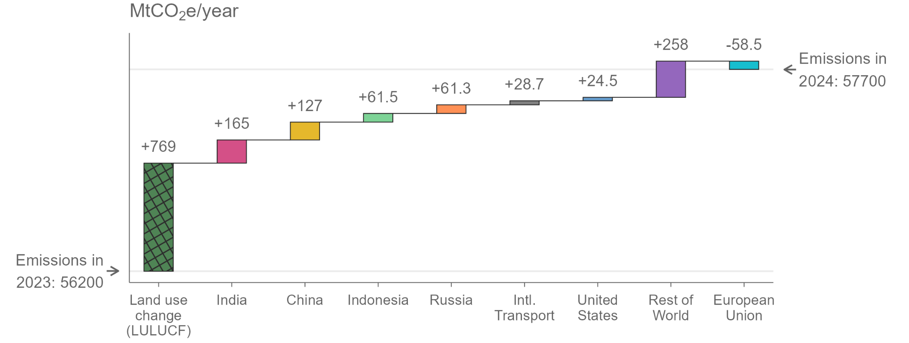
Figure 2.3: Contributions to the change in 2024 greenhouse gas emissions. Sources: Crippa et al. (2025), Friedlingstein et al. (2025). The hatched land use change (LULUCF) estimate refers to the global change.
Contributions by current, per capita and historic emissions differ across the high emitters and world regions. Per capita GHG emissions are above the world average of 6.4 tons of CO₂ equivalent (tCO2e) in the United States of America, the Russian Federation, China and the European Union, and remain significantly below it in Indonesia and India. The per capita emissions of Least Developed Countries is 1.5 tCO2e. In terms of historic cumulative CO₂ emissions (including LULUCF), the United States of America has produced the most global CO₂ emissions to date, followed by China and the European Union (Appendix Figure 10). By contrast, India, the Least Developed Countries and the African Union have only produced a minor share of historic cumulative emissions, despite being highly populous countries and regions. A swathe of countries with high per capita and historic emitters have still to peak in their emissions, including Russia and the USA which this year returned to growth.

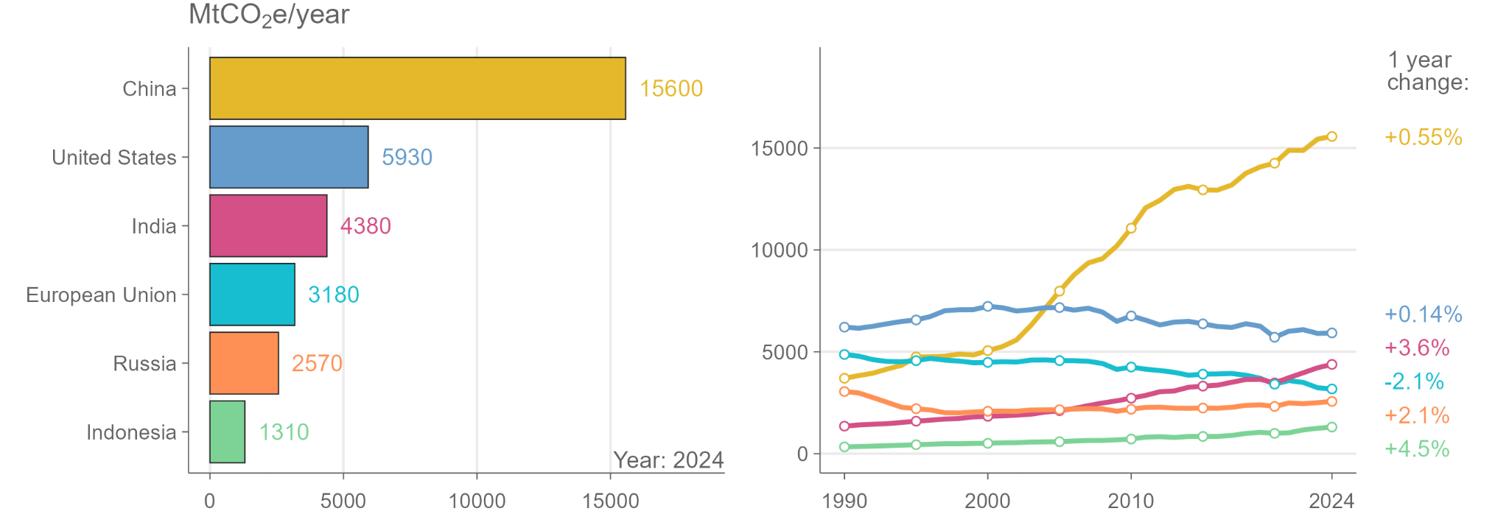
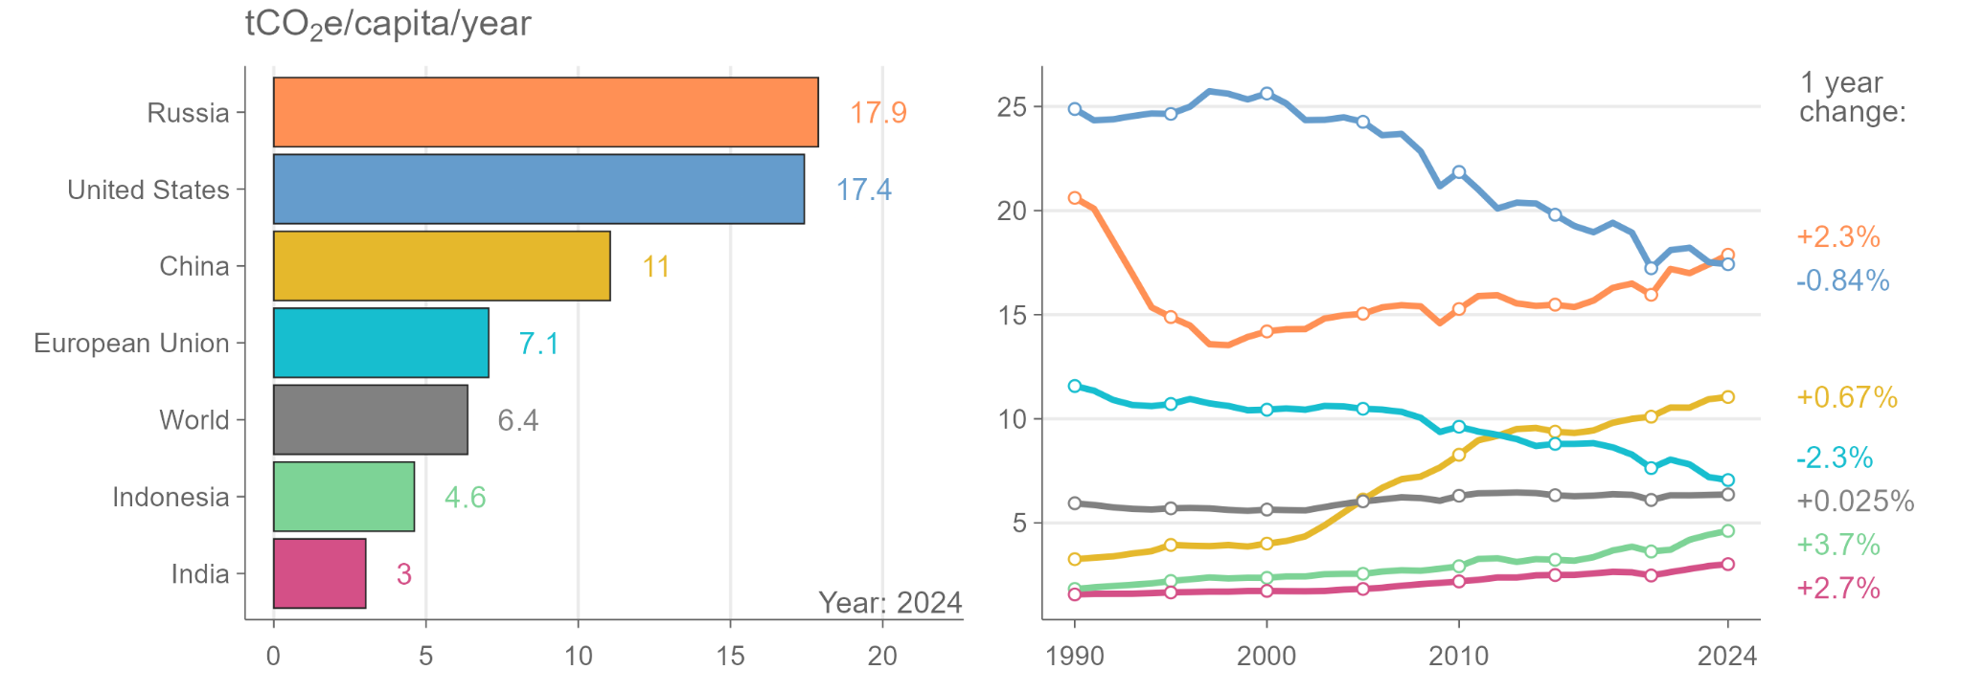
Figure 2.4: Total and per capita greenhouse gas emissions of the top six emitters. Sources: Crippa et al. (2025), World Bank (2025). Emissions from land use change (LULUCF) are excluded.

Box 3: Transparency in national greenhouse gas emissions reporting
At COP24 Katowice, countries agreed to submit Biennial Transparency Reports (BTRs) by December 31, 2024. These were to contain, among other documents, a set of Common Reporting Tables (CRTs) with the national greenhouse gas inventory of each country. Annex I countries have been submitting national inventories in a similar format for many years, but for many other countries the BTRs have led to substantially improved emissions data gathering under the agreement.

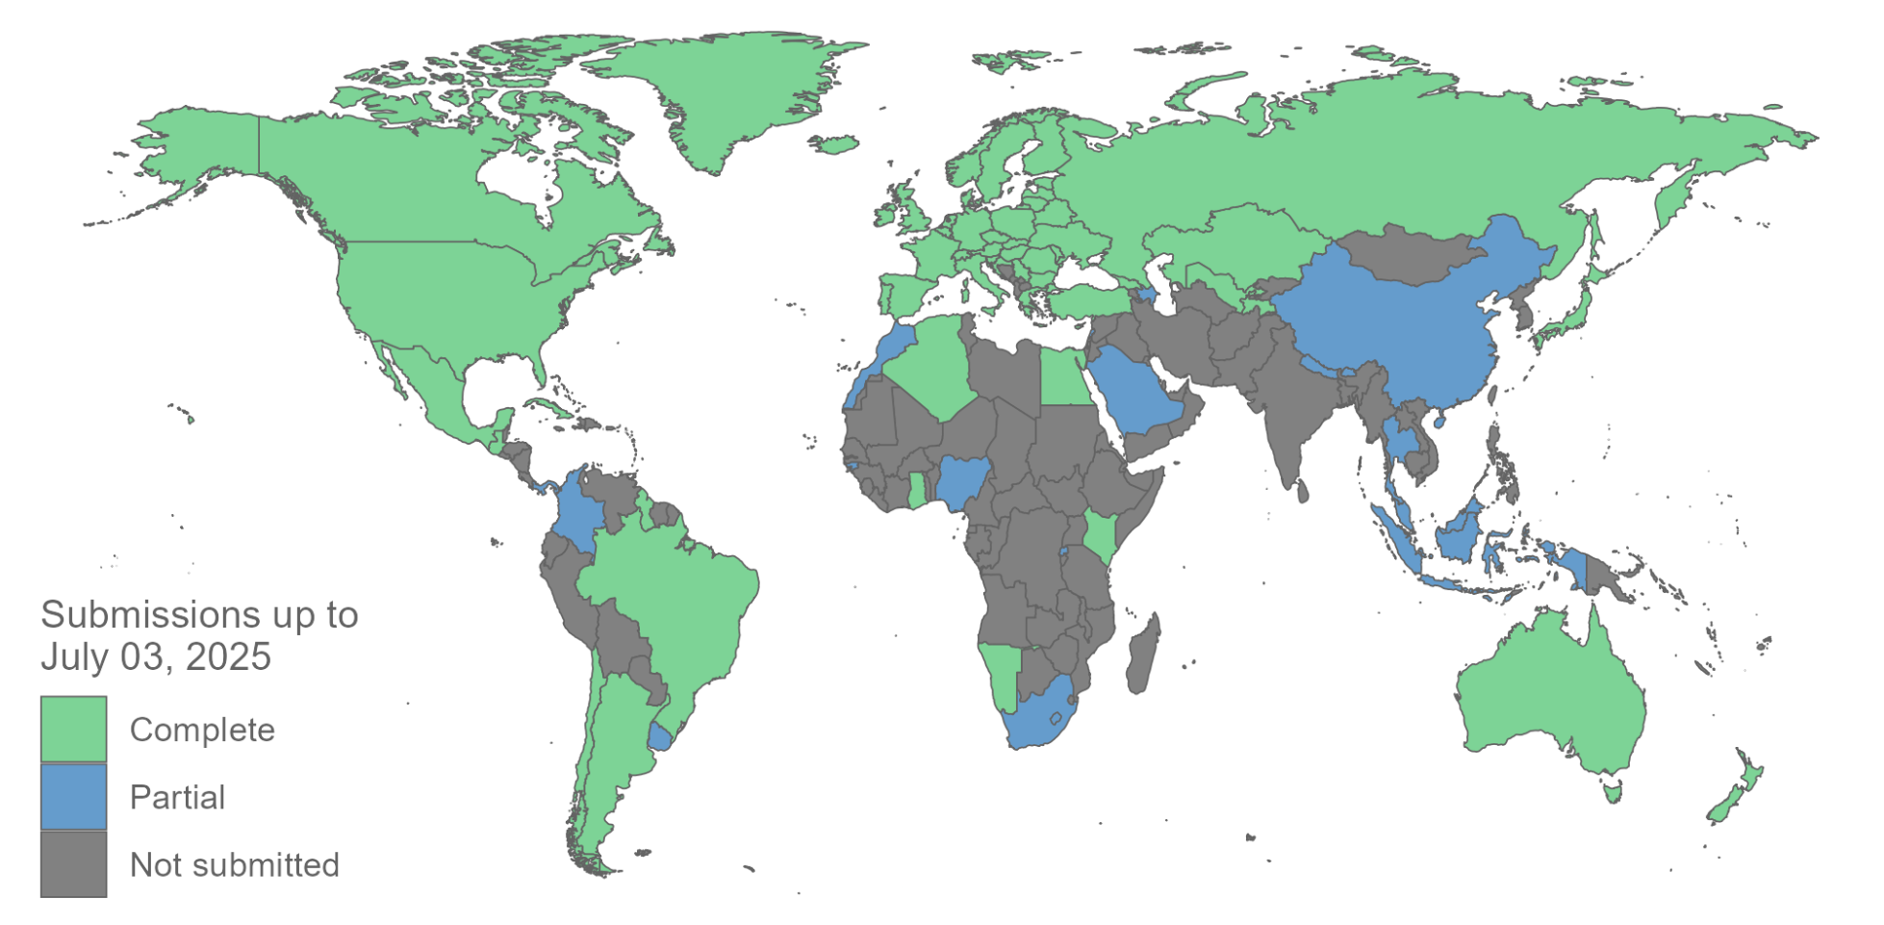
Figure 2.5: Completeness of Common Reporting Tables in the first Biennial Transparency Reports.
As of July 3rd, 83 countries have submitted a CRT with their BTR (Figure 2.5). Of these, 61 CRTs are complete in that they cover the period 1990 to 2021 across the full scope of gases and sectors under the Paris Agreement. While least developed countries and small island developing states may choose to submit BTRs at their discretion, 8 have done so (Cuba, Guinea-Bissau, Guyana, Maldives, Mauritius, Nepal, Rwanda and Singapore).
By contrast, many countries have yet to provide either partial or complete CRTs. Among the high emitters these include India, while China reported just 3 years of data. A further 6 countries submitted CRTs, but did so with inconsistent, missing or incorrectly formatted data (Lamb, 2025). It should also be noted that the United States failed to submit a National Inventory Report in 2025, which is an obligation for Annex I countries under the agreement.

The BTRs offer a first step towards a harmonised, transparent and timely global approach to emissions reporting, which is instrumental for informing national pledges and tracking progress towards them. Nonetheless, further improvements in reporting are required before a complete assessment of global emissions based on the inventories can be made.

Allen, M.R., Frame, D.J., Friedlingstein, P., Gillett, N.P., Grassi, G., Gregory, J.M., Hare, W., House, J., Huntingford, C., Jenkins, S., Jones, C.D., Knutti, R., Lowe, J.A., Matthews, H.D., Meinshausen, M., Meinshausen, N., Peters, G.P., Plattner, G.-K., Raper, S., Rogelj, J., Stott, P.A., Solomon, S., Stocker, T.F., Weaver, A.J., Zickfeld, K., 2025. Geological Net Zero and the need for disaggregated accounting for carbon sinks. Nature 638, 343–350. https://doi.org/10.1038/s41586-024-08326-8
Andrew, R.M., 2025. Global CO2 emissions from cement production. https://doi.org/10.5281/zenodo.14931651
Boakes, E.H., Dalin, C., Etard, A., Newbold, T., 2024. Impacts of the global food system on terrestrial biodiversity from land use and climate change. Nat Commun 15, 5750. https://doi.org/10.1038/s41467-024-49999-z
Crippa, M., Guizzardi, D., Pagani, F., Banja, M., Muntean, M., Schaaf, E., Becker, W., Monforti-Ferrario, F., Quadrelli, R., Risquez Martin, A., Taghavi-Moharamli, P., Grassi, G., Rossi, S., Brandao De Melo, J., Oom, D., Branco, A., San-Miguel, J., Vignati, E., 2025. GHG emissions of all world countries.
Deng, Z., Zhu, B., Davis, S.J., Ciais, P., Guan, D., Gong, P., Liu, Z., 2025. Global carbon emissions and decarbonization in 2024. Nat Rev Earth Environ 6, 231–233. https://doi.org/10.1038/s43017-025-00658-x
EMBER, 2025. Global Electricity Review [WWW Document]. URL https://ember-energy.org/latest-insights/global-electricity-review-2025 (accessed 5.12.25).
Energy Institute, 2025. Statistical Review of World Energy.
European Commission, 2025. Global land use carbon fluxes.
Forster, P., Storelvmo, T., Armour, K., Collins, W., Dufresne, J.-L., Frame, D., Lunt, D.J., Mauritsen, T., Palmer, M.D., Watanabe, M., Wild, M., Zhang, H., 2021. Chapter 7: The Earth’s Energy Budget, Climate Feedbacks and Climate Sensitivity, in: Climate Change 2021: The Physical Science Basis. Contribution of Working Group I to the Sixth Assessment Report of the Intergovernmental Panel on Climate Change. Cambridge University Press, Cambridge, United Kingdom and New York, NY, USA, pp. 923–1054. https://doi.org/10.1017/9781009157896.009
Forster, P.M., Smith, C., Walsh, T., Lamb, W.F., Lamboll, R., Hall, B., Hauser, M., Ribes, A., Rosen, D., Gillett, N.P., Palmer, M.D., Rogelj, J., Von Schuckmann, K., Trewin, B., Allen, M., Andrew, R., Betts, R.A., Borger, A., Boyer, T., Broersma, J.A., Buontempo, C., Burgess, S., Cagnazzo, C., Cheng, L., Friedlingstein, P., Gettelman, A., Gütschow, J., Ishii, M., Jenkins, S., Lan, X., Morice, C., Mühle, J., Kadow, C., Kennedy, J., Killick, R.E., Krummel, P.B., Minx, J.C., Myhre, G., Naik, V., Peters, G.P., Pirani, A., Pongratz, J., Schleussner, C.-F., Seneviratne, S.I., Szopa, S., Thorne, P., Kovilakam, M.V.M., Majamäki, E., Jalkanen, J.-P., Van Marle, M., Hoesly, R.M., Rohde, R., Schumacher, D., Van Der Werf, G., Vose, R., Zickfeld, K., Zhang, X., Masson-Delmotte, V., Zhai, P., 2024. Indicators of Global Climate Change 2023: annual update of key indicators of the state of the climate system and human influence. Earth Syst. Sci. Data 16, 2625–2658. https://doi.org/10.5194/essd-16-2625-2024
Friedlingstein, P., O’Sullivan, M., Jones, M.W., Andrew, R.M., Hauck, J., Landschützer, P., Le Quéré, C., Li, H., Luijkx, I.T., Olsen, A., Peters, G.P., Peters, W., Pongratz, J., Schwingshackl, C., Sitch, S., Canadell, J.G., Ciais, P., Jackson, R.B., Alin, S.R., Arneth, A., Arora, V., Bates, N.R., Becker, M., Bellouin, N., Berghoff, C.F., Bittig, H.C., Bopp, L., Cadule, P., Campbell, K., Chamberlain, M.A., Chandra, N., Chevallier, F., Chini, L.P., Colligan, T., Decayeux, J., Djeutchouang, L.M., Dou, X., Duran Rojas, C., Enyo, K., Evans, W., Fay, A.R., Feely, R.A., Ford, D.J., Foster, A., Gasser, T., Gehlen, M., Gkritzalis, T., Grassi, G., Gregor, L., Gruber, N., Gürses, Ö., Harris, I., Hefner, M., Heinke, J., Hurtt, G.C., Iida, Y., Ilyina, T., Jacobson, A.R., Jain, A.K., Jarníková, T., Jersild, A., Jiang, F., Jin, Z., Kato, E., Keeling, R.F., Klein Goldewijk, K., Knauer, J., Korsbakken, J.I., Lan, X., Lauvset, S.K., Lefèvre, N., Liu, Z., Liu, J., Ma, L., Maksyutov, S., Marland, G., Mayot, N., McGuire, P.C., Metzl, N., Monacci, N.M., Morgan, E.J., Nakaoka, S.-I., Neill, C., Niwa, Y., Nützel, T., Olivier, L., Ono, T., Palmer, P.I., Pierrot, D., Qin, Z., Resplandy, L., Roobaert, A., Rosan, T.M., Rödenbeck, C., Schwinger, J., Smallman, T.L., Smith, S.M., Sospedra-Alfonso, R., Steinhoff, T., Sun, Q., Sutton, A.J., Séférian, R., Takao, S., Tatebe, H., Tian, H., Tilbrook, B., Torres, O., Tourigny, E., Tsujino, H., Tubiello, F., van der Werf, G., Wanninkhof, R., Wang, X., Yang, D., Yang, X., Yu, Z., Yuan, W., Yue, X., Zaehle, S., Zeng, N., Zeng, J., 2025. Global Carbon Budget 2024. Earth System Science Data 17, 965–1039. https://doi.org/10.5194/essd-17-965-2025
Gidden, M.J., Gasser, T., Grassi, G., Forsell, N., Janssens, I., Lamb, W.F., Minx, J., Nicholls, Z., Steinhauser, J., Riahi, K., 2023. Aligning climate scenarios to emissions inventories shifts global benchmarks. Nature 624, 102–108. https://doi.org/10.1038/s41586-023-06724-y
Global Forest Watch, 2025. . World Resources Institute, Washington D.C., USA.
Grassi, G., House, J., Kurz, W.A., Cescatti, A., Houghton, R.A., Peters, G.P., Sanz, M.J., Viñas, R.A., Alkama, R., Arneth, A., Bondeau, A., Dentener, F., Fader, M., Federici, S., Friedlingstein, P., Jain, A.K., Kato, E., Koven, C.D., Lee, D., Nabel, J.E.M.S., Nassikas, A.A., Perugini, L., Rossi, S., Sitch, S., Viovy, N., Wiltshire, A., Zaehle, S., 2018. Reconciling global-model estimates and country reporting of anthropogenic forest CO2 sinks. Nature Climate Change 8, 914–920. https://doi.org/10.1038/s41558-018-0283-x
Grassi, G., Peters, G.P., Canadell, J.G., Cescatti, A., Federici, S., Gidden, M.J., Harris, N., Herold, M., Krug, T., O’Sullivan, M., Pongratz, J., Sanz, M.J., Schwingshackl, C., Van Vuuren, D., 2025. Improving land-use emission estimates under the Paris Agreement. Nat Sustain. https://doi.org/10.1038/s41893-025-01565-1
Grassi, G., Stehfest, E., Rogelj, J., van Vuuren, D., Cescatti, A., House, J., Nabuurs, G.-J., Rossi, S., Alkama, R., Abad Viñas, R., Calvin, K., Ceccherini, G., Federici, S., Fujimori, S., Gusti, M., Hasegawa, T., Havlik, P., Humpenoeder, F., Korosuo, A., Perugini, L., Tubiello, F.N., Popp, A., 2021. Critical adjustment of land mitigation pathways for assessing countries’ climate progress. Nature Climate Change 11, 14.
Hong, C., Zhao, H., Qin, Y., Burney, J.A., Pongratz, J., Hartung, K., Liu, Y., Moore, F.C., Jackson, R.B., Zhang, Q., Davis, S.J., 2022. Land-use emissions embodied in international trade. Science 376, 597–603. https://doi.org/10.1126/science.abj1572
IEA, 2025a. Global Energy Review [WWW Document]. URL https://www.iea.org/news/growth-in-global-energy-demand-surged-in-2024-to-almost-twice-its-recent-average (accessed 5.12.25).
IEA, 2025b. Trends in electric car markets – Global EV Outlook 2025 – Analysis [WWW Document]. URL https://www.iea.org/reports/global-ev-outlook-2025/trends-in-electric-car-markets-2 (accessed 7.3.25).
IEA, 2025c. Energy demand from AI – Energy and AI – Analysis [WWW Document]. URL https://www.iea.org/reports/energy-and-ai/energy-demand-from-ai (accessed 7.3.25).
IPCC, 2025. Decision IPCC-LXII-8. Scoping of the IPCC Seventh Assessment Report (AR7). Intergovernmental Panel on Climate Change (IPCC), Hangzhou, China.
IPCC, 2022. Summary for Policymakers, in: Shukla, P.R., Skea, J., Slade, R., Al Khourdajie, A., van Diemen, R., McCollum, D., Pathak, M., Some, S., Vyas, P., Fradera, R., Belkacemi, M., Hasija, A., Lisboa, G., Luz, S., Malley, J. (Eds.), Climate Change 2022: Mitigation of Climate Change. Contribution of Working Group III to the Sixth Assessment Report of the Intergovernmental Panel on Climate Change. Cambridge University Press, Cambridge, UK and New York, NY, USA. https://doi.org/10.1017/9781009157926.001
Kolden, C.A., Abatzoglou, J.T., Jones, M.W., Jain, P., 2025. Wildfires in 2024. Nat Rev Earth Environ 6, 237–239. https://doi.org/10.1038/s43017-025-00663-0
Lamb, W., 2025. Tidy GHG Inventories. https://doi.org/10.5281/zenodo.14637347
Lamb, W., Andrew, R., Jones, M., Nicholls, Z., Peters, G., Smith, C., Saunois, M., Grassi, G., Pongratz, J., Smith, S., Tubiello, F., Crippa, M., Gidden, M., Friedlingstein, P., Minx, J., Forster, P., 2025. Differences in anthropogenic greenhouse gas emissions estimates explained. Earth System Science Data Discussions. https://doi.org/10.5194/essd-2025-188
Lee, D., 2025. Meeting the energy challenge posed by data centres is central to a green future. Nature 639, S33–S33. https://doi.org/10.1038/d41586-025-00747-3
Peng, X., Liang, J., Chen, H., Chen, J., Zhang, J., Sun, Q., You, P., 2025. Heterogeneous drivers of decarbonization in the global power sector. Environ. Res. Lett. 20, 064044. https://doi.org/10.1088/1748-9326/add9b1
Pongratz, J., Schwingshackl, C., Bultan, S., Obermeier, W., Havermann, F., Guo, S., 2021. Land Use Effects on Climate: Current State, Recent Progress, and Emerging Topics. Current Climate Change Reports 7, 99–120. https://doi.org/10.1007/s40641-021-00178-y
Pongratz, J., Smith, S.M., Schwingshackl, C., Dayathilake, L., Gasser, T., Grassi, G., Pilli, R., 2024. Chapter 7: Current levels of CDR, The State of Carbon Dioxide Removal - 2nd Edition., in: Smith, S.M., et al. (Eds.), The State of Carbon Dioxide Removal - 2nd Edition.
Reining, S., Wussow, M., Zanocco, C., Neumann, D., 2025. Roof renewal disparities widen the equity gap in residential wildfire protection. Nat Commun 16, 463. https://doi.org/10.1038/s41467-024-55705-w
Schwingshackl, C., Obermeier, W.A., Bultan, S., Grassi, G., Canadell, J.G., Friedlingstein, P., Gasser, T., Houghton, R.A., Kurz, W.A., Sitch, S., Pongratz, J., 2022. Differences in land-based mitigation estimates reconciled by separating natural and land-use CO2 fluxes at the country level. One Earth 5, 1367–1376. https://doi.org/10.1016/j.oneear.2022.11.009
UNFCCC, 2021. COP26: Pivotal Progress Made on Sustainable Forest Management and Conservation | UNFCCC [WWW Document]. URL https://unfccc.int/news/cop26-pivotal-progress-made-on-sustainable-forest-management-and-conservation (accessed 7.4.25).
West, C., Rabeschini, G., Singh, C., Kastner, T., Bastos Lima, M., Dermawan, A., Croft, S., Persson, U.M., 2025. The global deforestation footprint of agriculture and forestry. Nat Rev Earth Environ 6, 325–341. https://doi.org/10.1038/s43017-025-00660-3
Wiebe, R.A., Wilcove, D.S., 2025. Global biodiversity loss from outsourced deforestation. Nature 639, 389–394. https://doi.org/10.1038/s41586-024-08569-5
World Bank, 2025. World Bank Development Indicators [WWW Document]. URL http://data.worldbank.org/ (accessed 7.7.23).

